**Assignment-2**

**Course: Web Development for Mobile Devices**

**Course Code: MAD105-MAD2401SB**

**Submitted by: Rohit Andava (A00185299)**

**Submitted to: Reena Verma**

**Home Page**

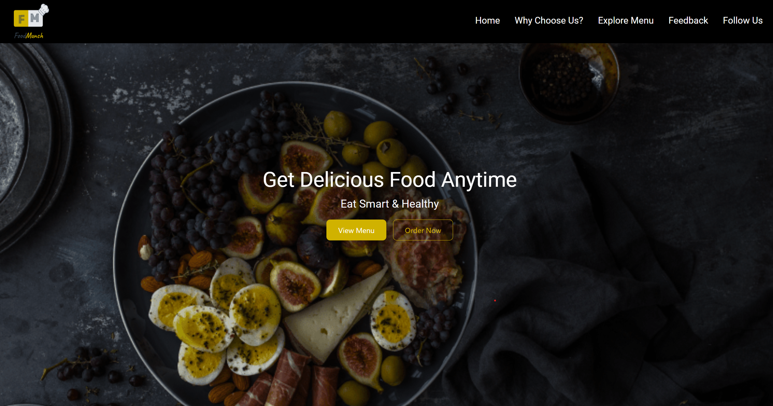

**Why Choose us.**

**Explore Menu**

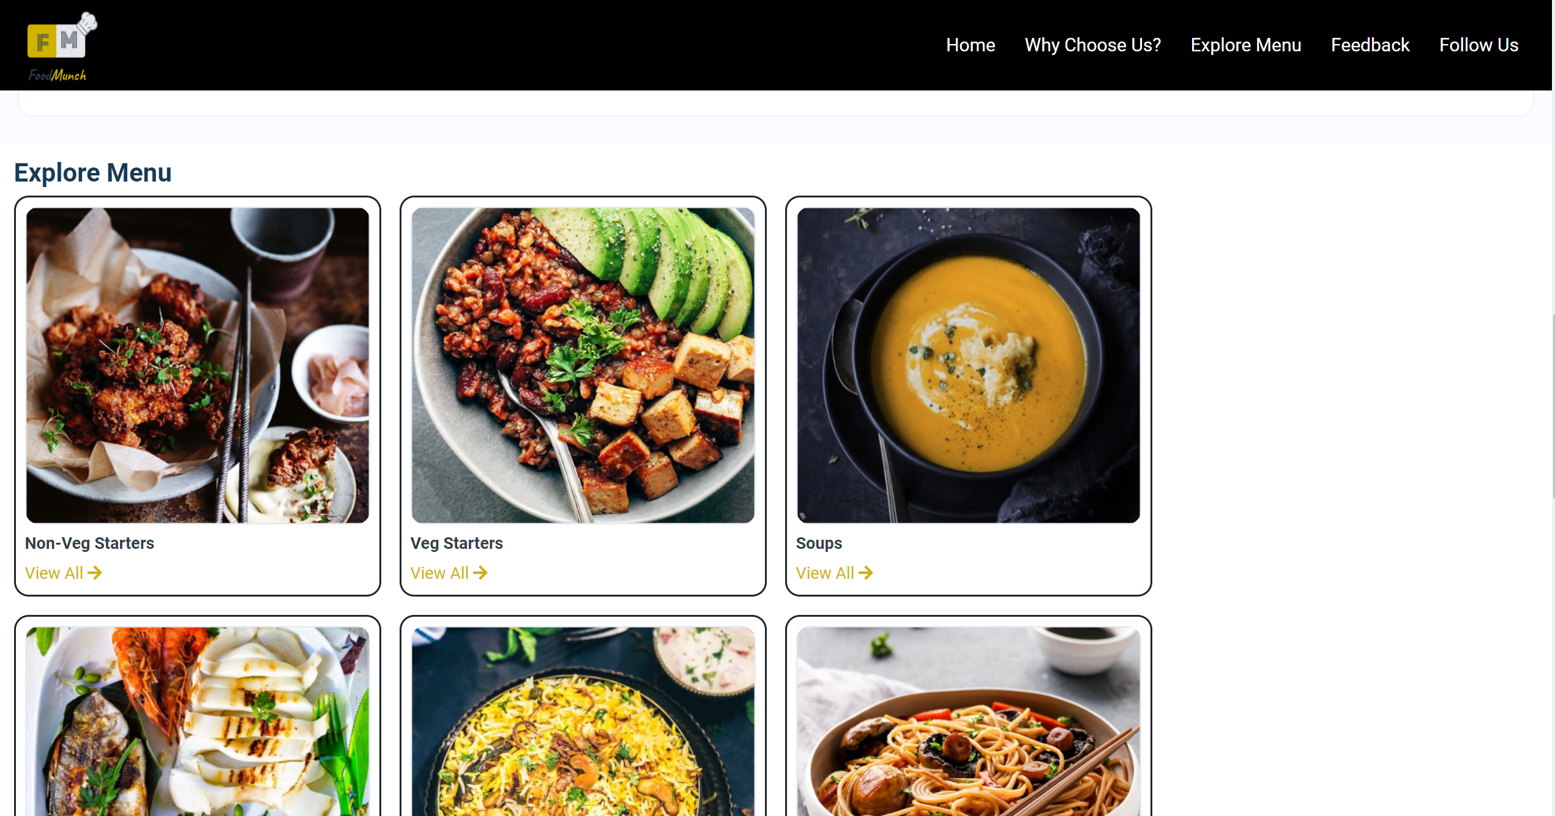

**Feedback Form**

